Test Paper No____

APPLECROSS SENIOR HIGH SCHOOL

YEAR 11 HUMAN BIOLOGY

DO NOT MARK THIS PAPER IN ANY WAY.

Time Allowed 50 minutes.

Answer questions 1-30 on the multiple choice answer sheets. Follow the directions on the answer sheet.

Answer all other questions on the writing paper provided.

1. Implantation occurs about how many days after fertilisation?

a) 1 day b) 12 days
c) 28 days d) 6 days

- Which of the following is not a sign of early pregnancy?
a) morning sickness b) abdominal swelling
c) absence of menstrual periods d) breast swelling and tenderness

3. The most vulnerable time for adverse effects on the development of the foetus is during;

a) conception b) the first three months
c) the last three months d) birth.

4. Between what days in the normal 28 day menstrual cycle is fertilization considered most likely?

a) 0 – 5 b) 6 – 9
c) 12 – 16 d) 19 – 21

5. The hollow ball of cells which is in the uterus three or four days after fertilisation is called the:

a) foetus. b) trophoblast.
c) primitive streak. d) blastocyst.

6. The ectoderm is the primary tissue which gives rise to:

a) the digestive system b) muscle, bone and blood vessels.
c) extra-embryonic tissues d) skin and the nervous system.

- The membrane enclosing the foetus in a fluid filled sac is the:
a) amnion b) allantois
c) chorion d) yolk sac

8. Amniotic fluid is important by serving as a medium;

I for providing nutrients to the embryo
II to provide constant temperature surrounding the embryo
III to act as a shock absorber for the embryo

a) I only. b) I and II only.
c) II and III only. d) I, II and III.
.

9. The gestation period for humans is about:

a) 365 days b) 280 days
c) 28 days d) 4 days

10. .Which of the following contraceptive methods has shown to be the least successful in achieving unwanted pregnancies?

a) condom b) rhythm method
b) oral contraceptives d) intra – uterine devices

- After conception, the main organs are established by the end of the
- third day b) second week
c) eighth week d) fourth month

12. Which of the following substances does a pregnant mother receive from the placenta?

A carbon dioxide . B glucose.
C urea. D amino acid.

a) A only. b) D only. c) B and C only.
d) A and D only. e) A and C only.

13. The most widely used oral contraceptive is similar in its action to the hormone:

a) testosterone b) progesterone and oestrogen
c) Pituitrin c) oestrogen alone

14. F.S.H. is a hormone which has the function of;

a) promoting lactation after child-birth.
b) controlling reabsorption of water from kidney tubules.
c) stimulating follicle cells and ensuring the development of a maturing ovum.
d) regulating metabolic rate.

- Which of the following statements about pregnancy is INCORRECT?
- During late pregnancy women urinate more often because the expanding uterus exerts pressure on the bladder.
- The lungs of the foetus are collapsed until birth
- The chorion is made from the mother’s cells
- The umbilical vein carries oxygenated blood from the placenta to the foetus.

16. The hormone responsible for milk let down, and uterine contractions during labour is;

a) progesterone b) oestrogen
c) oxytocin d) luteinising hormone

17. A short time after a baby is born; the "after birth" is expelled. This is the:

a) the membranous bag that contained the baby.
b) wastes produced by the developing foetus.
c) watery fluid called colostrum.
d) placenta and associated foetal membranes.

18. If both sperm ducts (vas deferens) are cut in a process called vasectomy, then:

- sperm will be produced but not seminal fluid.
- neither sperm nor male hormones will be produced.
- Sperm will be produced but male hormones will not.
- Sperm will not be released but male hormones will be produced.

19. Identical twins are the result of

- A single ovum fertilised by two sperm.
- One sperm dividing and fertilising two ova.
- One fertilised ovum dividing to form two embryos.
- Two ova fertilised at the same time by two different sperm.

20. Human semen consists of sperm cells and secretions from various glands. One of these secretions contains concentrations of the simple sugar, fructose.

The function of this sugar in the semen would be to

- provide a source of energy for the sperm.
- prevent the sperm from drying out and thus dying.
- provide a medium through which the sperm can swim to the ovum.
- maintain the ideal level of acidity for sperm survival.
21. The uterine tubes (Fallopian tubes) lead from the ovary to the

- uterus.
- vagina.
- corpus luteum.
- bladder.

22. The function of the structure labelled F on the diagram below is to

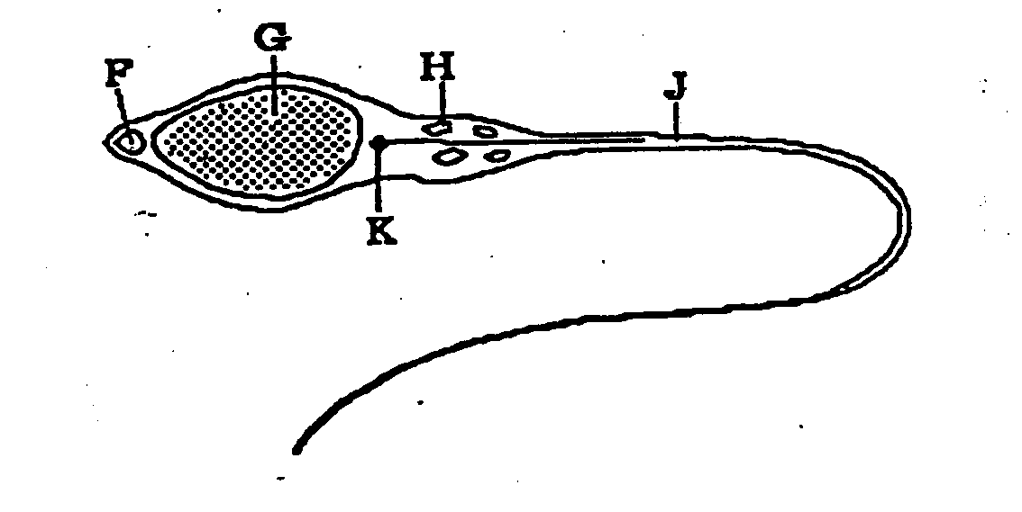
- protect G.
- prevent other sperm from swimming too near.
- attract the egg to the sperm.
- digest the egg membrane so that G can penetrate the egg.

23. Fertilisation is possible for only a brief part of each female cycle because

- there is only one ovum and many sperm.
- the corpus luteum degenerates very quickly after ovulation.
- both live sperm and ovum must be present for fertilisation.
- spermatozoa are released rhythmically at ovulation.

24. The single cell formed after fertilisation is called

- an embryo.
- a foetus.
- a gamete
- a zygote.

25. In the diagram of the female reproductive system shown below, fertilisation would occur at the point marked

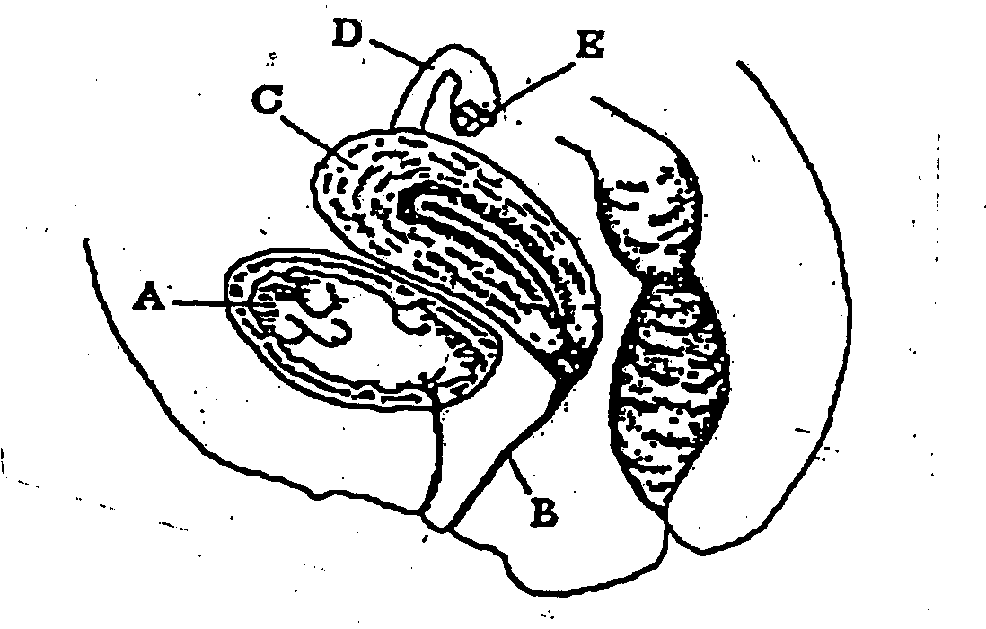
- B.
- C.
- D.
- E.

26. The beginning of each menstrual cycle in a mature human female is

- when ovulation occurs.
- the last day of each month.
- when the egg reaches the uterus.
- when the lining of the uterus begins to break down.

27. Which of the following is the best definition of sexual reproduction?

- the production of offspring that are genetically identical to the parents.
- the result of two individuals mating.
- the production of offspring as a result of fusion of gametes.
- production of offspring by two parents.

28. Which of the following correctly shows the life span of an egg after ovulation, the life span of
sperm inside the female reproductive tract and the period over which fertilisation could
theoretically occur.

Life span of egg life span of sperm period available for fertilisation
- 24 hours 48 hours 72 hours
- 12 hours 72hours 72 hours
- 24 hours 72 hours 96 hours
- 24 hours 72 hours 144 hours

29. The correct labels for the structures marked 1 to 4 on the diagram below are

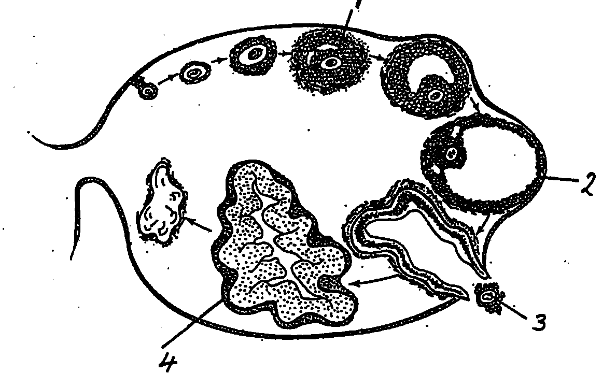

 | 1 | 2 | 3 | 4
a graafian follicle | corpus luteum | ovum | secondary follicle | Graafian follicle
b | Graafian follicle | secondary follicle | ovum | corpus albicans
c | ovum | secondary follicle | corpus luteum | Graafian follicle
d | secondary follicle | Graafian follicle | ovum | corpus luteum

30. After ovulation the empty follicle becomes

a) a corpus luteum.
b) a corpus albicans.
c) a Graafian follicle.
d) scar tissue.

31. A polar body

a) is at one end of the spindle during mitosis.
b) develops from the egg after fertilisation.
c) is produced when a cell divides unevenly during meiosis.
d) develops into a sperm during spermatogenesis.

32. Oogenesis occurs in

a) an ovum.
b) the ovary.
c) the uterus.
d) a uterine tube.

33. Which of the following methods of “contraception” operates largely by preventing implantation rather than by preventing fertilization?

a) the diaphragm b) Intra-uterine device
c) the “pill” d) condom

SECTION B: ANSWER THESE QUESTIONS ON PAD PAPER
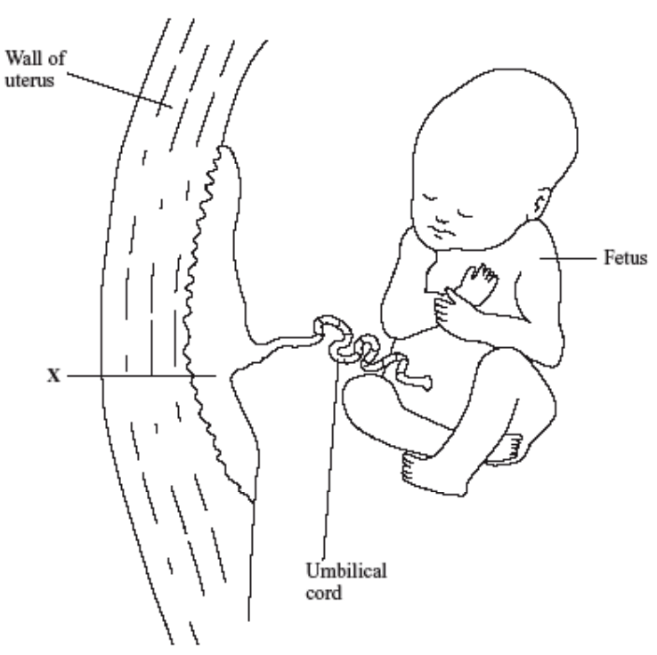
21. (a) The structure labelled X contains blood vessels of the mother and foetus.
What is the name of structure X?
(1)

(b) The membrane between the mother’s blood and the blood of the foetus is very thin.
    - Explain how this helps a foetus to receive oxygen. (1)
    - Name two substances (other than oxygen) that this membrane allows through. (1)

22. The diagram below illustrates the circulation of a foetus during pregnancy. State four ways in which foetal circulation differs from normal adult circulation. For each difference, give the reason for the difference.
(8)
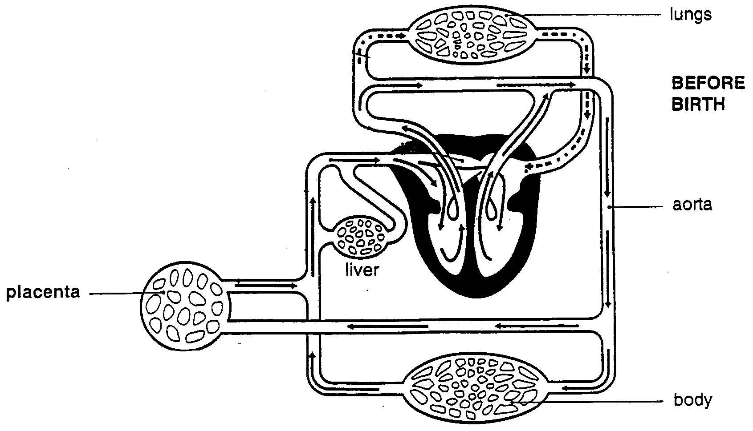

23. Describe the events that occur in each of the three stages of labour. (4)
24. Use a table to compare mitosis with meiosis. (5)

Human Biology Test - Reproduction
Written Section
Q. 36
a) X = Placenta 1 mark

b) i) oxygen must diffuse – thin villi (.5) in placenta enable aid diffusion (.5) 1 mark

ii) glucose, CO2, nutrients, alcohol (name .5 mark, reason .5 each) 1 mark

Q. 37
First way
Left and right atria (.5) have foramen ovale (.5) allowing blood to flow into both chambers without going to the lungs (1 )
Second way
Ductus arteriosus (.5) – connecting the pulmonary artery and aorta which bypasses the lungs (.5) 1

Third way
Ductus venosus (.5) allows blood to the inferior vena cava bypassing the liver(.5) 1

Fourth way
Aorta to placenta (.5) via the umbilical artery (.5) bypassing the body

Total of marks

Q.38

Stage 1
- Contraction of uterus every 30 minutes
- Cervix dilates
- Baby forced further into pelvis
- Last 8 – 9hours
- Uterus, vagina and cervix line up to form delivery canal (any 3 – 1 mark each)

Stage2
Amniotic fluid released
Baby delivered
Lasts 20 min. – 2 hours
Vagina stretched
Head turns to face mother’s back
After head emerges, baby’s head turns sideways to face mother’s hips ((any 3 – 1 mark each)

Stage 3
Baby begins to breath
Umbilicus clamped and cut
Uterus contracts expelling after birth of placenta, amnion, choroid and umbilical cord
Blood supply to plcenta closes off. (any 3 – 1 mark each)

